Welcome to School Name Here
Packed Lunch and snack Policy leaflet

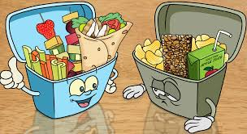

Our Packed lunch and snack guide has been created in consultation with SLT,
Catering Team, the Government school food standards guidelines, and FSA guidance on Allergy awareness

As a Nut Aware school, to protect some members of our school community with severe allergies - we request that children do not bring food into school containing nuts in any form.

Why do we have a policy for packed lunches and snacks?

Eating a healthy well balanced packed lunch is important to help children stay healthy, feel good, and improve their ability to learn.

Our packed lunch guidance has been developed in response to parent feedback and observations of children’s packed lunches and other snacks, that found some less healthy choices can affect energy levels, concentration, behaviour, and health.

Healthier packed lunches focus on the 4 main food groups of the Eatwell plate, foods in the small purple section should not be sent in to school to be eaten for lunch or snack times.

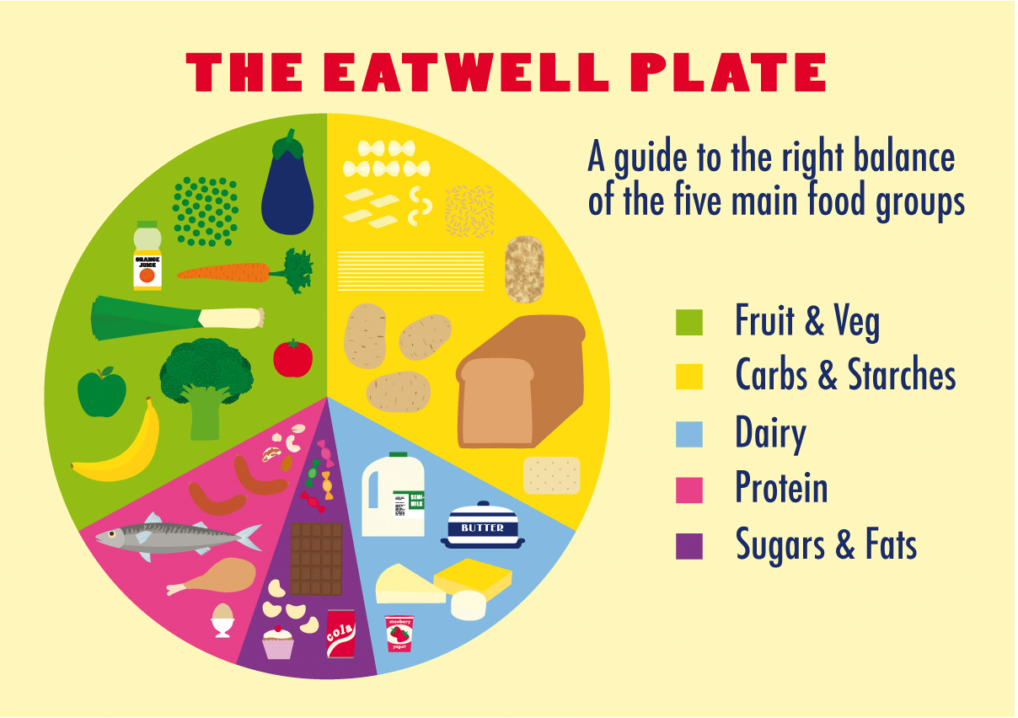

The aim of our policy is..

To support and complement our efforts to become an awarded.
Healthy school.

We believe all children should eat a healthy lunch and so this guidance is to help packed lunches to be as healthy as our home cooked school meals which exceed the Governments school food nutritional standards.

http://www.schoolfoodplan.com/actions/school-food-standards/

How we will support the policy-

- We will ensure that free fresh drinking water is available at all times and strongly encourage water only policy. It isn’t essential to include a drink with a packed lunch as water is provided.

- We can provide menu ideas and practical advice for healthy affordable packed lunches and snacks.

- We will reward pupils that bring healthy lunches and snacks with praise, certificates, or prizes.

- We will allow pupils that bring in packed lunches and eat school lunch to sit and eat lunch together.

- We will ensure we will listen to our parent/carer and pupil views to ensure this policy is fair and meets everyone’s needs.

- Our traffic light system is in line with the School food Standards for School Meals.

